# NEWS RELEASE

**Fronius iWave: innovative 3-in-1 product from the technology leader**

**Ready for every challenge**

**The iWave from Fronius – launching in January 2022 – is an intelligent, high-end series that sets new standards in quality, flexibility and connectivity. The TIG power source enables perfect weld seams to be produced on all weldable materials. It also possesses multiprocess capability and comes with a host of innovative features. The modular system design assures a customized solution whatever your welding requirements – both now and in the future.**

Fronius developed the iWave to enable the very best TIG weld quality and flawless results to be produced on different metals. The innovative Option CycleTIG provides for maximum control over the arc and targeted heat input. Further highlights include improved ignition control and greater ease of use with intuitive operation. Whether welding pressure vessels, pipes or the most demanding requirements in medical technology and food & drink production – in fact, all applications where avoiding pores and temper coloration is critical – the iWave is the perfect choice. The series is available as of now in power categories 190 A to 500 A.

**Universal solution with Multiprocess PRO**

Multiprocess capability is important if you are switching between different welding tasks on a day-to-day basis. The new iWave really proves its worth here with sophisticated TIG technology and is ideally suited for manual metal arc welding – even with cellulose electrodes. The Multiprocess PRO option is a real winner, giving the user unlimited access to all MIG/MAG processes in power categories from 300 A. This makes the iWave a multi-talented all-rounder producing outstanding welding results with all welding processes.

**Flexible, customizable and future-proof**

*"The iWave provides flexibility in that customers can individually choose the specific functions they actually need from a range of modular Welding Packages. The customer also has the assurance that they can add to the range of functions as and when needed"*, reveals Manuel Rumpl, Head of Strategic Product Management at Fronius International GmbH. Starting with standard TIG or standard MIG/MAG applications, the iWave enables upgrades to the full Fronius range, including the Cold Metal Transfer (CMT), Pulse Multi Control (PMC) and Low Spatter Control (LSC) Welding Packages.

**Bluetooth, WLAN and NFC as standard**

The iWave supports the main communication standards and is ready for Industry 4.0. Modern wireless connections give welders greater freedom and security, allowing them to exploit the full potential of the device. Peripheral devices, such as remote control or the high-tech Vizor Connect welding helmet, can be wirelessly connected via Bluetooth. WLAN enables communication with other devices in the same network so the user can enjoy a whole host of digital advantages, such as central user management, real-time data transfer and rapid updates.

**Energy efficiency and long service life**

Fronius has really gone the extra mile in the iWave series, combining resource-conserving know-how with rugged, durable design. It is the first TIG power source on the market with a Real Energy (kJ) display and analysis feature. In addition, Power Factor Correction (PFC) provides for efficient energy consumption and no-load power consumption is always below 50 W.

Before a Fronius welding system can get the go ahead to enter production, it is subjected to a battery of load and endurance tests that it must pass. These tests go way beyond the standard requirements, and are the key to why our systems enjoy such a long service life. Moreover, in the event of servicing, the service-friendly design means the main components can be replaced with ease.

*3,166 characters (including spaces)*

For further information, please visit our website <https://www.fronius.com/en/welding-technology/product-information/iwave-tig-welding-system> or [www.fronius.com/iwave](http://www.fronius.com/iwave)

**Photos:**

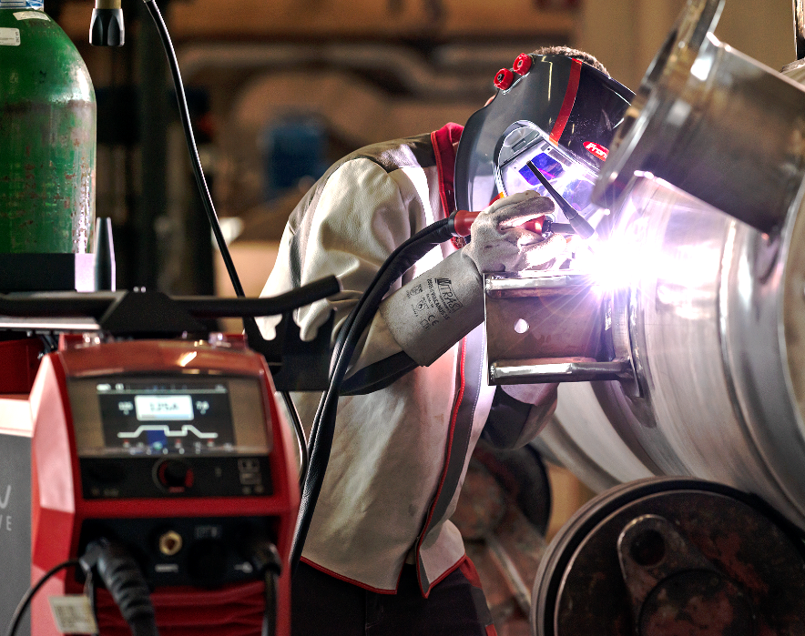

Image 1: The iWave combines a great TIG welding experience with maximum control and the ultimate in precision thanks to Fronius CycleTIG.

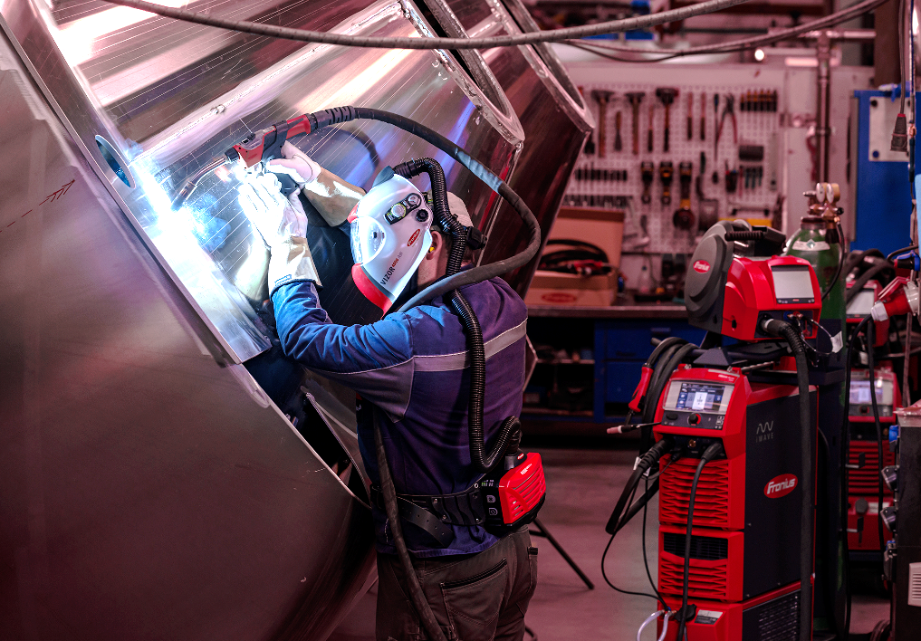

Image 2: Multiprocess PRO turns the high-end TIG power source into a fully-fledged MIG/MAG welding system that, in addition to the standard program, can be upgraded to include CMT, PMC and LSC as required.

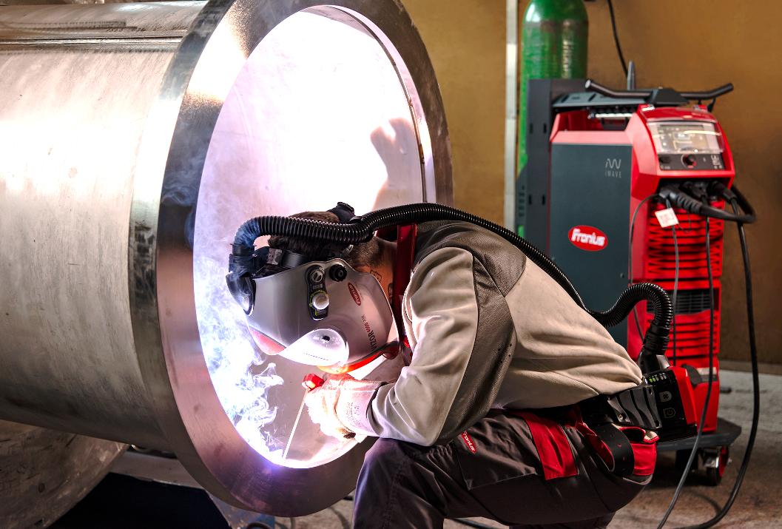

Image 3: There are virtually no limits to what the iWave can do, including when it comes to manual metal arc welding – even enabling the use of Cel electrodes.

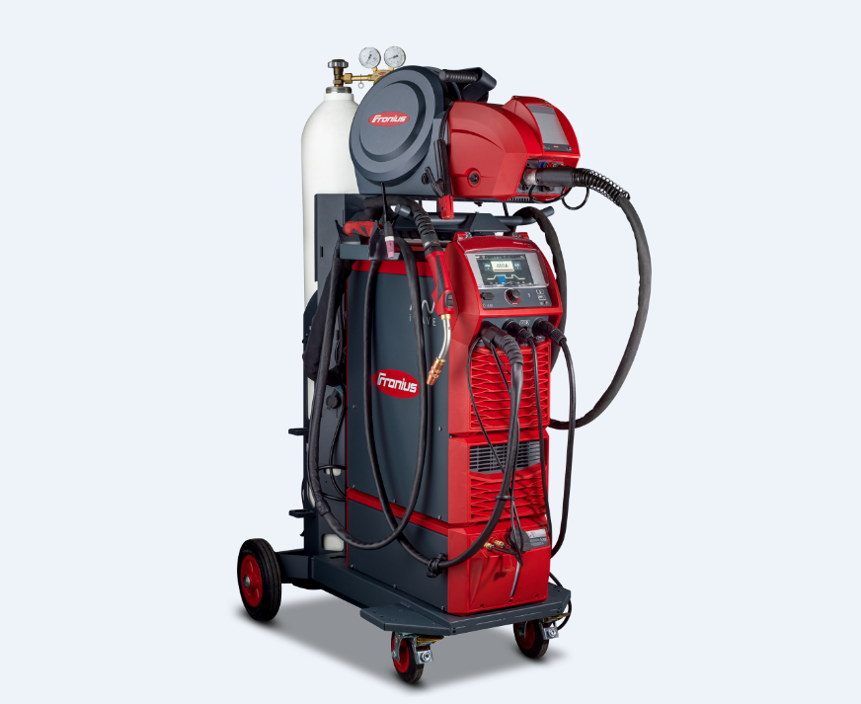

Image 4: The modular system design allows customers to customize their iWave to their own requirements.

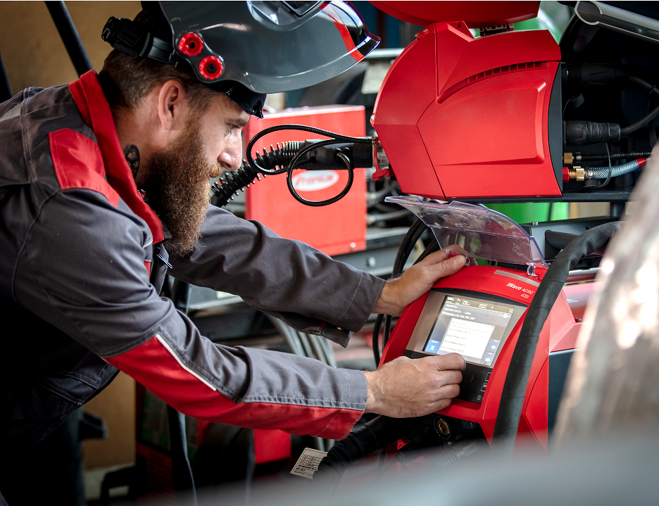

Image 5: The intuitive dynamic, graphics-based operating concept takes the user straight to the setting they need, and is available in more than 30 languages.

Copyright to photos: Fronius International GmbH, reproduction free of charge

**Business Unit Perfect Welding**

Fronius Perfect Welding is an innovation leader for arc welding and a global market leader for robot-assisted welding. As a systems provider, the Fronius Welding Automation division also implements customized automated complete welding solutions, for the construction of containers or offshore cladding for example. The range is rounded off by power sources for manual applications, welding accessories, and a broad spectrum of services. With more than 1000 sales partners worldwide, Fronius Perfect Welding has great customer proximity.

**Fronius International GmbH**

Fronius International GmbH is an Austrian company with headquarters in Pettenbach and other sites in Wels, Thalheim, Steinhaus and Sattledt. With 5.660 employees worldwide, the company is active in the fields of welding technology, photovoltaics and battery charging technology. 92% of its products are exported through 36 international Fronius subsidiaries and sales partners/representatives in over 60 countries. With its innovative products and services and 1,321 granted patents, Fronius is the global innovation leader.

**For more information, please contact:**

Fronius International GmbH, Communication / Public Relations

Froniusplatz 1, A-4600 Wels, Austria,

E-Mail: [pressestelle-pw@fronius.com](mailto:pressestelle-pw@fronius.com)

**Please send an author's copy to our agent:**

a1kommunikation Schweizer GmbH, FAO Kirsten Ludwig,

Oberdorfstraße 31 A, 70794 Filderstadt, Germany,

Tel.: +49 0 711 9454161-20, e-mail: [kirsten.ludwig@a1kommunikation.de](mailto:kirsten.ludwig@a1kommunikation.de)

For more exciting updates, visit our blog at blog.perfectwelding.fronius.com and follow us on Facebook (froniuswelding), Twitter (froniusintweld), LinkedIn (perfect-welding), Instagram (froniuswelding) and YouTube (froniuswelding)!